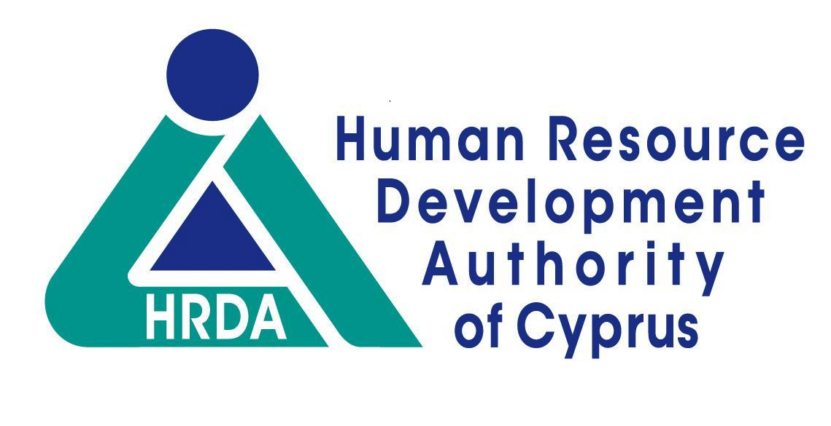

TRAINING PROGRAMME RECORD

Notes:
- The Training Programme Record is completed only for those training courses where HRDA has requested it. It is attached to the “Employer’s Application for Subsidy” form which is submitted to HRDA after completion of the course.
- A different page is completed for each week of training.
- The Record is checked and signed by the training course instructor/trainer.
4. The subjects and/or activities covered in the programme are entered in detail, in the space “Description of Activity”.

Programme Title :

Trainee’s name : ……………………….………………………………………………………………………….
Employer : ……………………………………………………………………………………………………….
Training provider : ………………………………………………………………………………………………
Training location : Country : ……………………………….. City : ………………………….……
Training duration (Days) ….……………………………………………………………………………
Training period : From : ……………………………… To : ………………………………………

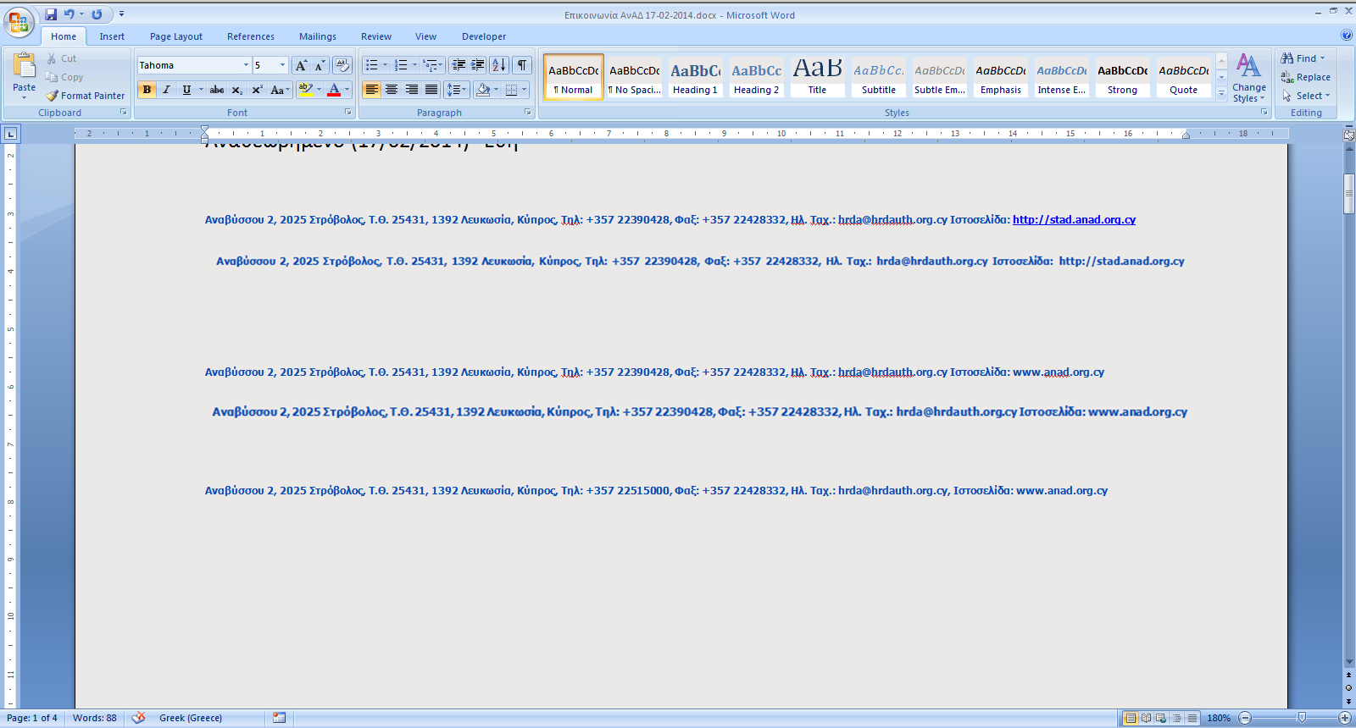

ΙΣΧΥΕΙ ΑΠΟ 2/10/2018

WEEK NO:

DAY & DATE | DESCRIPTION OF ACTIVITY |  | TRAINEE´S SIGNATURE
Monday
…… / …… / ……
Tuesday
…… / …… / ……
Wednesday
…… / …… / ……
Thursday
…… / …… / ……
Friday

…… / …… / ……
Saturday

…… / …… / ……
Sunday
…… / …… / ……
Trainer´s Comments: ………………………………………………………………………………………………………………
………………………………………………………………………………………………………………
………………………………………………………………………………………………………………
………………………………………………………………………………………………………………

………………  Date | ………………………………………………. Trainer´s Name | …………………………  Trainer´s Signature

